

INCEPTION SPECIFICATION

Kentucky HBPA IT Project



February 23, 2017

Alexander Pierce

KIMBERLY ROETEN

JOE SPALDING

EVAN WALSH

*Serious Business*

System Request

**Project Sponsor** KHBPA Executive Director – Martin Maline

KHBPA Executive Assistant – Sara Toomey

**Business Need** The Kentucky HBPA has initiated this request out of a desire to accomplish 3 primary business goals:

1. Protect long-term business sustainability by strengthening points of systemic weakness in existing data management processes
2. Increase membership by creating additional value for members and reducing existing barriers for new members
3. Increase reach and improve public relations with the goal of exerting some influence on the political and regulatory environment

**Business Requirements**  The KHBPA website and IT system must:

* Allow updates of news, an events calendar, and page content
* Allow new members to sign up
* Facilitate donations
* Allow for processing of claims and benefits
* Allow for printing of or online submission of documentation and forms
* Back up critical data to a central secure location
* Allow for uploading of pictures or videos
* Link to related sites and social media

**Business Value** Benefits this system will create for KHBPA:

* An increase in membership and in the rate of membership growth over time
* Time savings of an estimated 100 hours and cost savings of an estimated $8,196 in year 1
* Mitigation of system failure and data-loss risk
* Extended reach and improved community engagement
* Improved ability to disseminate critical information to current and future members

**Special Constraints** Deadline: End of year 2017.

**System Request – Detailed Narrative**

The Kentucky HBPA’s current information system lacks functionality which, if implemented, would yield a significant return on investment, promote long-term growth, and mitigate risk. Put simply, the KHBPA is leaving money on the table.

To be more specific KHBPA faces a number of technical challenges which currently stand in the way of their primary business goals. They would like to protect their business from the risk of a data-loss disaster, but their data is currently being stored in disparate locations with no back-ups. Their goal of increasing membership is impeded by the current difficulty of signing up as a new member and the limited marketing reach KHBPA currently has. Despite being a charity, KHBA has no simple way of accepting donations. They also have no way of allowing members to conveniently print forms and documents from home or a remote location. Finally, KHBPA has limited ability to connect with its members and create extra value for them. Ideally, KHBPA would like to drive members to connect with them online, but right now there isn’t much incentive for a user to do so.

To begin addressing these issues we recommend that KHBPA adopt the following set of business process changes and additions. First, to ensure business continuity, customer data should be stored in a single central cloud-hosted location. Given KHBPA’s current dominant position in their market, data-loss is likely the greatest threat to the business, and this process change would reduce that threat to near zero.

Second, the KHBPA website should support new member registration through a simple web form. Reducing this barrier to entry could go a long way toward improving membership growth, especially among more tech-savvy horsemen.

Third, the KHBPA website should feature a “Donate” button which offers users the option of making a 1 time tax-deductible donation or an automatic monthly or annual donation. This could be implemented at a relatively low cost using a service such a Stripe or PayPal. This kind of implementation ensures that KHBPA never has to handle sensitive credit card information. A very convenient way of donating may result in a significant increase in revenue, especially if the project is successful in significantly increasing website traffic.

Fourth is a very small change that would have significant benefits for members; and that is to host important documents and forms on the website and allow users to print them.

Last, the KHBPA website currently lacks features which compel users to keep returning. A consistently updated calendar of events, news feed, and photo gallery could have a profoundly positive impact on traffic. This additional traffic would make the website a much more effective platform for promoting legislative causes and communicating important issues to members.

These solutions are all very feasible. From a technical perspective, this project is relatively small and deals with technologies that have been tried and tested millions of times by thousands of similar websites. None of them are exceptionally complex or beyond the capacity of the developers.

Economically, the organization’s $1,000 budget is more than sufficient to cover the estimated monthly costs of the project. In fact, it’s reasonable to expect that the project will generate more revenue than it costs, particularly in the medium to long term.

The organization is an ideal candidate to manage the processes being considered. It’s staff, with minimal training, is well-equipped to handle the new demands that will be placed on them.

Process Models

# AS-IS Process Model

The as-is process model (below) shows the processes supported by your current website along with the navigation flow a user follows to get to each of them. The navy-blue rectangles indicate that the user has a choice to make about where to go next. The blue circles show the beginning and end points of navigation.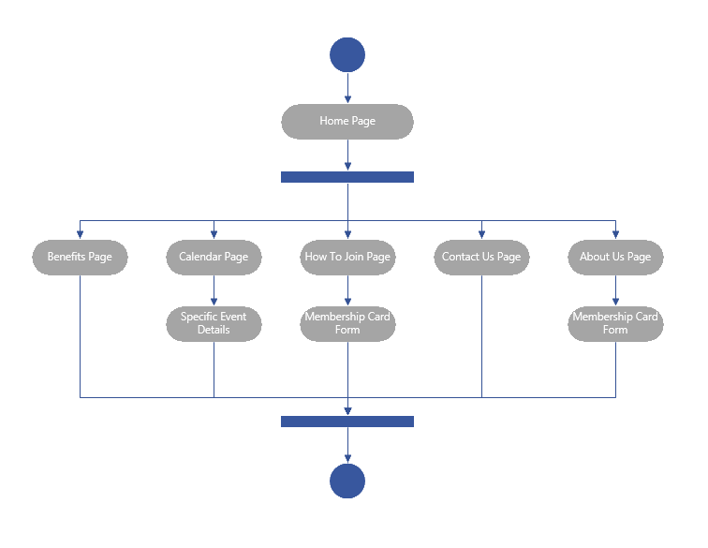

# TO-BE Process Model

The to-be process model (below) demonstrates the processes which your website will be able to perform on its own after our proposed system is implemented.

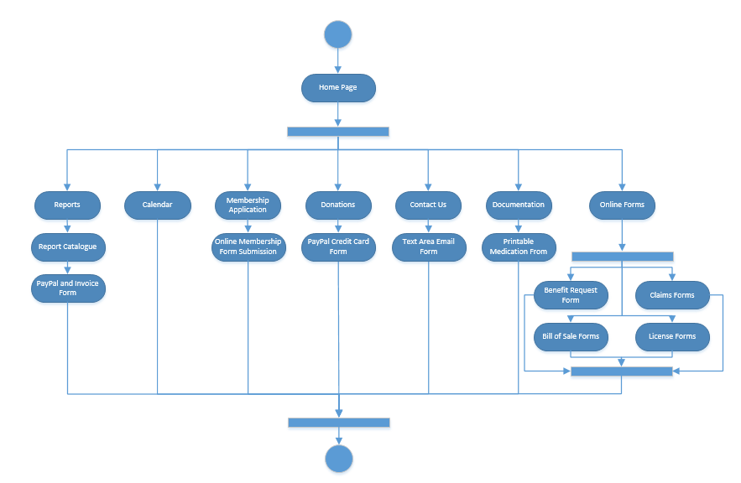

System Requirements

# Functional Requirements

1. The website will process transactions electronically.
2. The website will be able keep track of members through a back-end database.
3. The website will be able to associate documentation and reports with users in the database.
4. The website will allow users to contact the KHBPA through email.
5. The website will contact users when they need to be contacted, such as when a report request has been filled.
6. The website will be directly integrated with the KHBPA social media accounts.
7. The website will allow users to make donations to KHBPA
8. The system will keep track of and allow for management of a calendar of events
9. The system will support management of news items
10. The system will keep a database of links to outside pages
11. The system will support storing and managing submitted claims
12. The system will store photos and videos
13. The system will track admin-created polls and support embedding them
14. The system will store and allow downloading of medication information documentation
15. The system will store and allow downloading of a license form
16. The system will store and allow downloading of a bill of sale form
17. The system will support online benefits form submission and store related data
18. The system will allow users to provide feedback through a question form with a free text input
19. The system will allow users to publicly advertise that they are potential owners or trainers
20. The system will store and report contact info for the board of directors

# Non-Functional Requirements

1. The website content will be easily editable by employees of KHBPA.
2. The website will be visually distinct from similar organizations.

Use Cases

# Narrative – Use Cases

The following table describes the “Use Cases” handled by the proposed web site. These are named in a way that describes the action a user would take. Each action is taken by an “Actor”, or type of user. These Actors are organized in a hierarchy where all Admins are also Members, and all Members are also Users. Some actions can be performed by anyone but some are limited to members or further limited to administrators. Each use case includes a brief description of the use and the steps involved. Each use case is also tied to a system requirement number (these can be found on the previous page).

# Use Cases

|  |  |  |  |
| --- | --- | --- | --- |
| **Name** | **Actor** | **Description** | **System Req. ID** |
| **Creates account** | User | A user creates an account by providing personal information, an email address, and a password. By doing so this user becomes a member of the KHBPA and gains the benefits of membership (access to members-only features). | 2 |
| **Makes a donation** | User | A user has decided that they would like to contribute financially to the KHBPA, so they will make a one-time or recurring donation. To do so they will enter PayPal or credit card information along with the amount they would like to donate and then confirm the donation | 7 |
| **Creates an event** | Admin | An administrator would like to add an event to the event calendar so they choose a name for their event, a description, and a date and time. Once this information is submitted, the event is added to the public calendar for all users to see. | 8 |
| **Posts a news item** | Admin | An administrator would like to add a news item to the feed so they choose a title and text. Optionally they may also include a link, if the news item is posted on another page. Once this information is submitted, the news item is created in the feed with a date time stamp available for all to see. | 9 |
| **Posts a link** | Admin | An administrator would like to direct users to a particular page and therefore would like to post a new link. To do so they must enter a link title and a link address then submit. Once submitted, the new link appears in the links section of the page | 10 |
| **Submits a claim** | Member | A member would like to submit a claim for a horse that has been injured or euthanized on the track. After clicking a submit claim button they are directed to a claim form to fill out. Once filled out, they submit the form to KHBPA where it waits for approval. | 11 |
| **Uploads a picture** | Member | A member would like to upload a KY horse racing related picture to the public gallery. To do so the member selects the picture and uploads it to the server. Once on the server the picture is visible to all KY HBPA admins who can approve it to be posted. Once approved, the picture appears in the gallery. | 12 |
| **Creates a poll** | Admin | An administrator would like to create a poll for all users of the site or members of the KY HBPA to participate in. To do so the admin will first create a straw poll on a separate site, www.strawpoll.me. Once the poll is created, the KY HBPA site will allow administrators to embed the poll using the strawpoll.me embed iframe. | 13 |
| **Votes on a poll** | User | A user wishes to vote on a poll created by a KY HBPA admin. The poll itself will be embedded in the main page in the polling section, so for users voting is as simple as clicking one of the options and then the "Vote" button. | 13 |
| **Requests medication info** | User | A user would like to view or print medication info. To do so they simply click the medication info button from the documents section and select any of the uploaded medication info documents. From there the document is sent to the user where it can be viewed or printed. | 14 |
| **Requests license form** | User | A user would like to view or fill out a license form. The license forms are uploaded to the server so that when a user requests one it can be downloaded and filled out immediately. | 15 |
| **Requests bill of sale** | User | A user would like a bill of sale document. To get one they must follow the documents link, then choose the Bill of Sale option. The bill of sale document is then sent to the user where it can be viewed or printed. | 16 |
| **Requests a report** | User | A user would like a report from equiline, equibase, or brisnet. The user fills out a simple form in which they describe the report they're looking for. This form is sent to KY HBPA where it can be interpreted. If KY HBPA needs more information, they can call or e-mail the user, but if not they will find the report, pay for it, download it, and send it to the member or keep it in the office for pick-up. | 3 |
| **Signs in** | Member | A member signs in to the website using their e-mail address and password chosen when they created their account / signed up for the HBPA. This gives them access to all members-only sections and features of the website. | 2 |
| **Requests profile info** | Member | A member clicks a button to view their profile info. This shows them all of the information they entered when signing up. | 2 |
| **Edits profile info** | Member | A member clicks a button to edit their profile info. This shows them all of the information they entered when signing up and allows them to modify it. For example if their phone number or address changes, they can update them here. | 2 |
| **Requests calendar of events** | User | A user would like to see the current calendar of events. To do so they'll simply click the Events link and be directed to a page that shows all of the events currently posted on the calendar. | 8 |
| **Requests photo gallery** | User | A user would like to see the photo gallery. To do so they'll simply click the Photos link and be directed to a page that shows all of the photos that have been uploaded. The most recent of these photos might also be available from the main page so alternatively the user may simply click a link below photos on the main page to see the full gallery. | 12 |
| **Submits benefits form** | Member | A member would like to submit a benefits form. From the benefits page they'll click a link to fill out the form. Once filled out and submitted, the form will go to KY HBPA where it will await approval. | 17 |
| **Provides feedback** | Member | A member would like to provide some feedback to KY HBPA so they click a "Feedback" button. From here they'll be asked a few questions and then given the option to type any message they like. This feedback will be stored in the database and sent to KY HBPA for review. | 18 |
| **Sends e-mail blast** | Admin | An admin would like to send a message to all members. An e-mail list stored in the database is used for the group message and the e-mail is sent to everyone on the list. | 2 |
| **Posts potential owner** | Member | A member would like to declare that they are a potential owner. To do so they just set this flag in their profile and it will become visible to anyone looking for an owner. | 19 |
| **Posts potential trainer** | Member | A member would like to declare that they are a potential trainer. To do so they just set this flag in their profile and it will become visible to anyone looking for a trainer. | 19 |
| **Requests contact info** | User | A user would like to see contact infor the the KY HBPA or for any of the members of its board of directors so they click the "Contact Us" link and are taken to a page with names and e-mail addresses for the KY HBPA board and the KY HBPA itself. This page also includes information about office hours, and addresses of KY HBPA offices. | 20 |
| **Sends message to KHBPA** | User | A user would like to message the KY HBPA so they click the "Contact Us" link and fill out the form to send a message. Alternatively, they may use the contact e-mail address found on this page to send an e-mail to the KY HBPA. | 4 |

Architecture Considerations

The following page will go over the system architecture as well as the reasoning behind it. This will include all of the unique software and hardware features that our new system will consist of.

First off is the program we plan to implement for accepting both donations and payment for any forms that they may request from the new KHBPA site. The two foremost software we want to use are either PayPal or Stripe. Both have their pros and cons, with Stripe somewhat cheaper, but PayPal is more user friendly.

With a new site, we do plan on shifting away from the host that the KHPBA uses currently and moving to GoDaddy. GoDaddy allows for different levels of membership based on what the user needs. We would most likely go with the Economy edition, it comes with 1 site, unlimited bandwith and 100 gigabytes of storage. With this amount of storage we can easily store the forms we wanted. GoDaddy also has an easy to use help page with plenty of videos to help guide users through their products and features.

If we do go with a GoDaddy account to host our new site, they do also offer the ability to host databases as well. This, in combine with Access that comes with their Microsoft Office 365 membership, will allow for simple hosting and editing of a database that can hold all the members they have without needing to spend much more on it, as well as the ability to directly access the database, bypassing the need to use tools such as MySQL or similar, more developer heavy toolkits.

It was also discussed that polling the membership base would be a desired feature. With GoDaddy e-mail marketing, you can implement SurveyMonkey, which is quite popular. You can select from multiple surveys if you have a list of them, allowing for someone to create surveys early and just add it to the site when the appropriate time comes. With a SurveyMonkey account you can send out via e-mail a link to your survey and get the results you want in a simple, time-efficient way.

Risk Analysis

This section will review the possible risks and discuss what makes them risks. Each one will either be assigned a high level of risk or a low one, as laid out in the later sections.

The high risks are primarily going to be the activities that we believe will be hardest to implement, whether it is because of the level of technology needed, or if we are adding new features that we have only a few examples to draw from. Low risks will be ones that are easier to manage, as we either have plenty of information to draw from, or we actually know how to use and add the feature.

Creating an account, the first use case, would be a low risk item. We already have a wireframe of membership forms and a general idea of what we want so it should give us no problems. Making a donation is another low risk item. GoDaddy offers integration with both PayPal and Stripe, our two primary payment methods, as such we see no problems getting a donation page up and running. Creating an event could be a high risk item, we have few interactive calendars to go off of, and if users have problems with it, it may drive some people away from the site.

Posting a news item is a low risk item. Using the Wordpress program that GoDaddy uses, the admin would simply need to log into the site and type up the news, even give it some nice editing, and post it to the site. Posting a link follows the same vein as a news item, just adding a link to the main site or whatever page you need it on, making this another low risk item. Submitting a claim online will be a low risk item as well, we have plenty of other sites who have form submitting capabilities, as well as some other forms we can draw from. Uploading a picture may be a high risk item, we will need to find some place for the picture to be stored for easier access to the administrators and a simple form for them to choose what they want to upload.

Creating and voting on polls will be low risk, we plan on also signing up the KHBPA with a SurveyMonkey account. SurveyMonkey will allow them to create and send out polls to any user whose e-mail address is on file. Admins can also combine it with their GoDaddy site to quickly post links to their site. Requests for certain forms, such as medication, license and bills of sale, would be a low risk item. Either we will have the forms up on the site for downloads, or the request form will go directly to an e-mail account so that it will be a faster process. Signing in will be a low risk item, we will just have the user create an account when actually signing up to join the KHBPA, and we can even have some pages protected by a password, so that only users may access it.

The process of actually seeing their personal profile, as well as editing it, will be low risk as well, simply a user info link at the top of the page should do, allowing them to see and edit the information that the KHBPA has for them. Having an actual calendar on site that the user can see is quite simple. This is a low risk item, as we will need just a calendar outline on the site. The photo gallery is a low risk item, as it will simply be a collage of pictures on its own page, possibly a listing of users who submitted them.

Submitting a benefits form will be a low risk item, we have a wireframe for this form as well, they will just need to click a link and it will take them right to the page they need. Providing feedback was also discussed a lot, we believe it will be a low risk to implement, a simple form with a name, possibly an email address box in case the KHBPA would like to contact the person providing feedback, and a textbox that the user will compose their review. Sending out an email blast is another low risk item to implement. With keeping lists of emails of users, either getting into the database, or potentially signing up for the Email Marketing feature that GoDaddy has, sending out mass emails should be ease.

Posting both trainers and jockeys will be a high risk item, we want to make sure that this can be a safe, easy way for the two to meet. We envision it to be almost similar to LinkedIn, where a jockey can post their resume, and possibly a listing of races one, horses ridden, and so on. Trainers could list what horses they have, possibly listing notable races that the horses have competed in, where their stables are, and the like. For requesting contact information, it will be low risk, we have a page from the KHBPA that already has the information and just need to give it a more interactive and modern look. Under this, actually contacting them will be a low risk item as well, we would just make their email addresses clickable, and to open up a blank message that they can send to the desired employee.

As for other areas of risk, low risk items will be ones most user friendly, whereas high risk will be the ones the items that require more of a tech savvy user. Using GoDaddy as a host will be low risk, they are quite user friendly and have many videos that give instructions on how one might want to edit their page or how to use all the features that GoDaddy has to offer. To use Access as their primary way of editing the database, it will be high risk at first as Access is not commonly used, but will become low risk as either we work with the people who will edit and use the database, or they learn through other methods such as online tutorials.

These are the risks we have identified in the process of updating the KHBPA site, through the elaboration phase, we plan on looking for more examples of sites that do have these high risk items and seeing just how they implemented them. We will also improve our forms if we find any sort of issue with usage, especially as some of the KHPBA users are not quite as tech savvy as others. We will be discussing with the KHBPA and seeing what features they do like, and being open to suggested changes as well as frequent updates to let them know the progress we have made.

Team Charter

**Team Goals** To succeed in this business, the group of Serious Business hopes to accomplish exactly what the Kentucky HBPA is looking for when it comes down to an accurate and trustworthy website for the organization. We hope to serve as a guide to the Kentucky HBPA and offer them useful tips to improving their information system and implement some possible solutions that we’ve put adequate thought into and have taken the time to develop. Our goal is to help make the Kentucky HBPA the best it’s ever been from the user’s standpoint while simultaneously making the certain business processes as less complicated as possible. How we plan to do that is to be frank towards them but to not come off as harsh with our words, and back up our proposals as accurately as possible, having each possible question that could arise during the presentation already answered.

**Team Meetings**  So far, meetings have been scheduled via email and they have worked out rather fine. Every time before a presentation or assignment is due, we try to make time to meet at least once or twice before, one of the meetings being the morning of to give us the chance of going over what we have before the actual time that it’s due. We try to split up the work as evenly as possible and help each other out if we have questions for each other. There is no specific agenda we follow, we take the information that we have and determine how the rest is going to be done, then for the rest of the time we work rather quietly and productively in the same space. Meetings will not be formally documented unless something comes up and we won’t be able to remember it, in that case we’ll have someone in charge of taking notes. When it comes to decisions, we decide together as a group what will be submitted for the rough and/or final drafts.

**Team Communications** Members of team Serious Business have been communicating through Google Drive and email and that’s where we have gathered most of our technical materials. For Iteration 1, emails are being sent back and forth from us and Sara (Kentucky HBPA). Ideas and decisions regarding our presentations and assignments have been discussed amongst our instructor during our class meetings and we shall expect his feedback to be rather critical yet helpful.

**Team Decisions** Our group shall build consensus by majority vote if necessary, but so far we have felt the need to incorporate that alternative because agreeing on certain things has not yet been difficult to accomplish between our group members. Our opinions and individual ideas have been rather interchangeable when it comes to work regarding the Kentucky HBPA. If any conflicts were to occur, all members of this team have to make an effort to resolve those conflicts whatever they may be, if their our own personal conflicts or client conflicts, we’ll come together as a group in person if possible, address these conflicts and settle them to the best of our ability. If anyone were to refuse to be a part of the discussion, that falls on them and that person alone and that person would lose their voice in vote so to speak because they intentionally did not show up to a group meeting. When it comes to business decisions, sometimes you will be forced to make them right on the spot whether or not you have people to back you up, and part of this class is to help prepare us for instances such as these and learn how to improvise.

**Project Repository** Project documentation is a very essential part of project management, and how we plan to maintain that is to make sure project requirements are fulfilled and to ensure that our credibility exists the entire way through.

Gantt Chart

# Narrative – Gantt Chart

This Gantt Chart has been organized in chronological order of task assignments for each class deadline and the time we as a group would like it done by. It appears that everyone in the group Serious Business has had some involvement in making this project successful, but because this semester has already flown by so quickly, organizing each other's time wisely and learning how to balance meeting times has been absolutely crucial. How we have planned everything out so far, from the day when we're able to start the next phase to the day we present our new ideas, has seemed to work out fine and despite the occasional heavy loads each task may require, we believe that we will be capable of achieving the solutions the Kentucky HBPA desires.

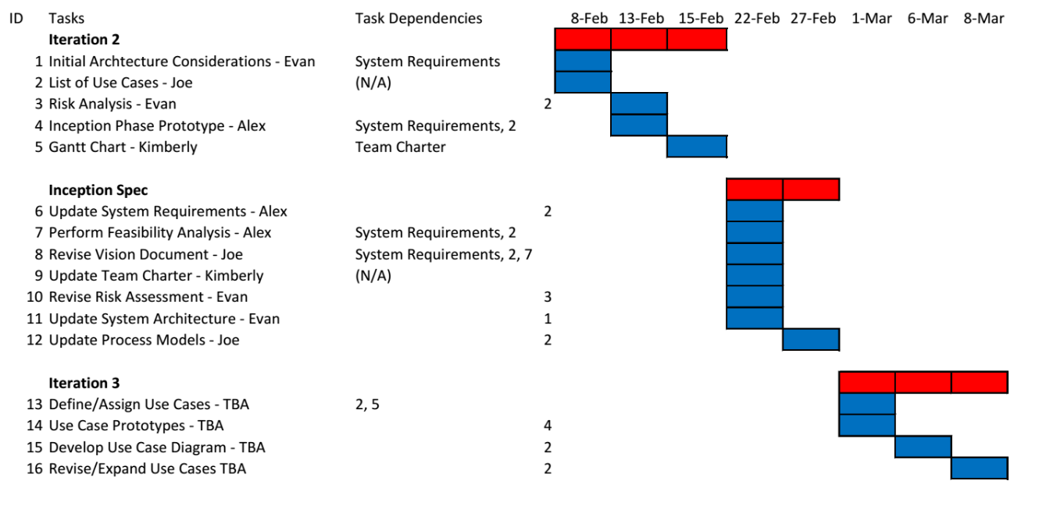

Prototypes – Benefit Form

# Description – Benefit Prototype

Pictured below you’ll find a prototype of the benefits or assistance request form. As the user scrolls down the page they will progress from screen 1, to screen 2, then screen 3. This form mirrors the existing form in the data it expects, but is presented in a mobile-friendly way. Once the user submits the form, the data will be available to KHBPA to process or print.

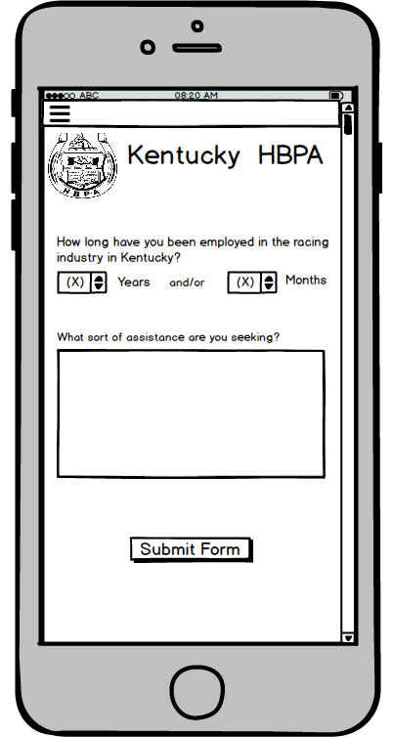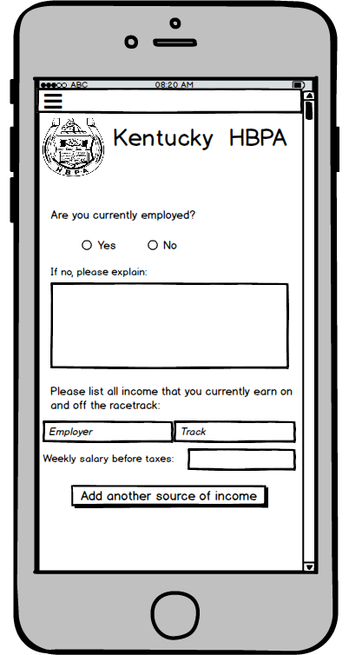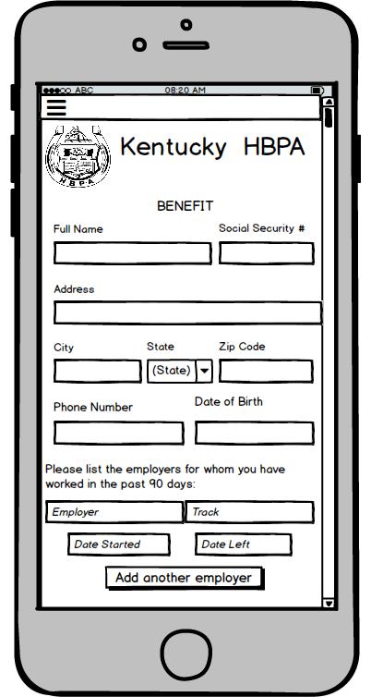

Screen 1 Screen 2 Screen 3

Prototypes – Sign Up Form

# Description – Sign Up Prototype

Pictured below you’ll find a prototype of a member sign up form. As the user scrolls down they will progress from screen 1 to screen 2. The information gathered by the form mirrors the existing member sign-up form with 1 difference, the new form expects the user to choose a password. This new form will serve 2 purposes: it will officially establish a person as a new member, and at the same time create an account for them on the website. Each time they visit the website they may choose to log in to take advantage of some members only features (submitting forms, requesting reports, etc.)

Once submitted this form will create an official member record in the database which you can read from.

Your reports of members would then be designed to read directly from the database and could therefore be accessible anywhere and anytime.

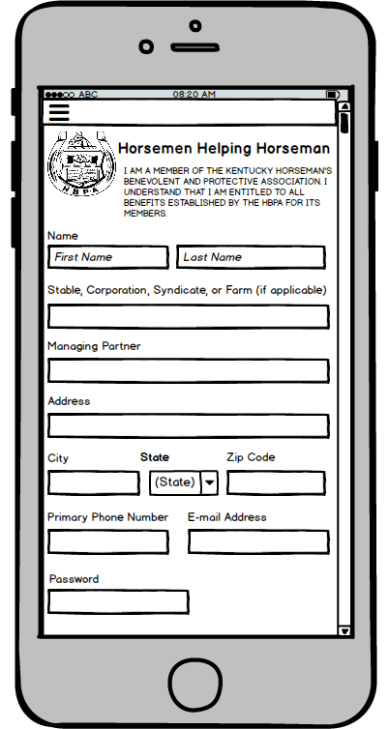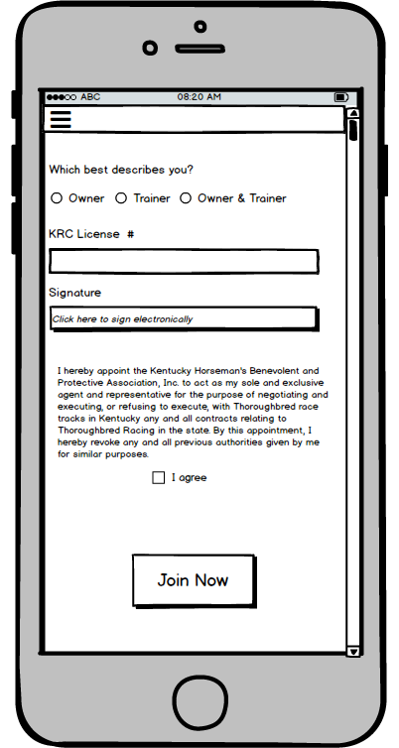

Screen 2

Screen 1

Prototypes – Donation Form

# Description – Donation Prototype

Pictured below you’ll find a prototype of a donation form. When the user clicks the “Donate Now” button on screen 1 they will progress to screen 2. When they click the “Next: Payment Details” button on screen 2 they will progress to screen 3. Screen 1 represents the “pitch”, the place to give reasons to consider donating. Screen 2 allows several options for the donation. It can be one-time, or recurring. The donation could also be made in honor of or in memory of an individual. In this case the idea would be to present this donation in a public facing way, perhaps by dedicating a section of the home page to showing donations made in someone’s name. As a last step, on screen 3, we will collect payment information and finalize the donation.

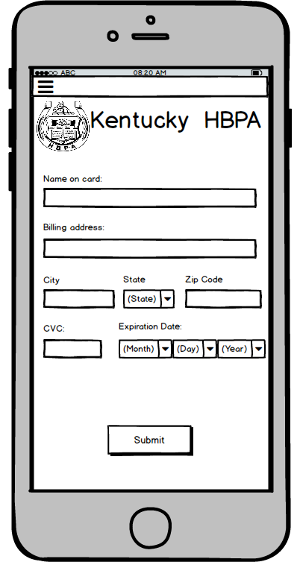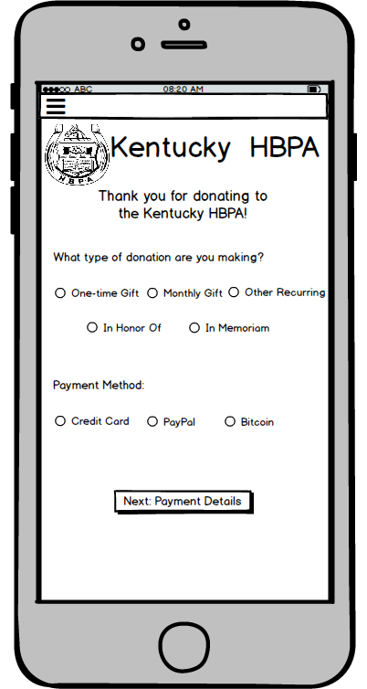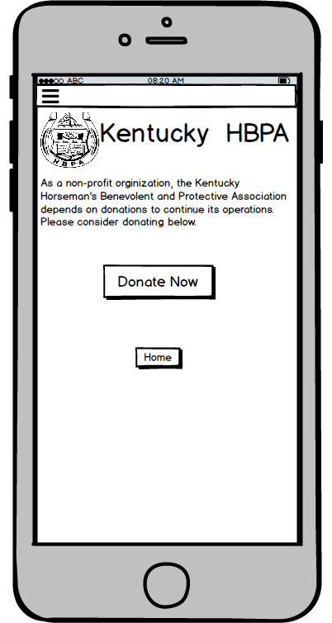

Screen 1

Screen 2

Screen 3

Prototypes – Contact Form

# Description – Contact Prototype

Pictured below you’ll find a prototype of a contact page with a form. As the user scrolls down the page they will progress from screen 1 to screen 2. On the KHBPA website users can already find a table that lists the title, name, and e-mail address of key people at the Kentucky HBPA. Screen 1 is showing what this might look like in the future, on a mobile device. In addition to the grid it includes office contact details and hours. This is combining the existing “Contact Us” page with the “Board of Directors” page.

Screen 2 below is a form where a user can enter their e-mail address, a subject, and a message. Clicking the “Submit Form” button will send their message to the contact e-mail address, [Kentuckyhbpa@gmail.com](mailto:Kentuckyhbpa@gmail.com).

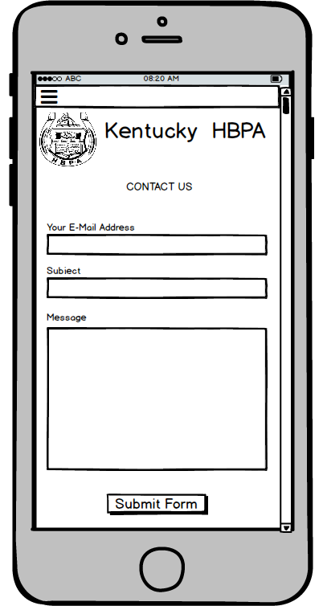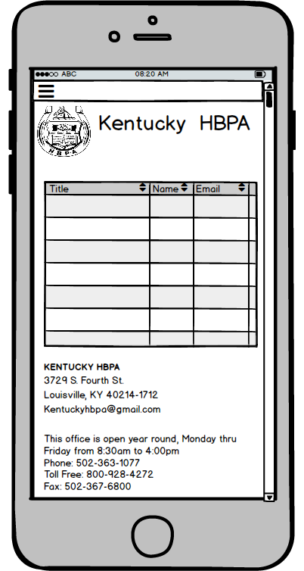

Screen 2

Screen 1